49^{h} National Conference
Orlando, Florida
Wednesday, May 30, 2018
State Assembly Leadership Forum
Seven (7) CE Credits
7:15 – 7:45 AM Continental Breakfast for SALF Registrants 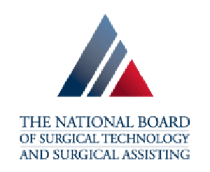
SPONSORED BY NBSTSA

7:45 - 8:00 AM Welcome and Introductions
HOLLY FALCON, CST, FAST, AST PRESIDENT

8:00 – 9:50 AM Lobbyist Lowdown: Meet the Insiders Who Give AST a Voice
Down at the Capitol
STEPHANIE WHALUM, ESQ., AST DIRECTER OF GOVERNMENT AFFAIRS
SARAH WOLFE, MCGUIREWOODS CONSULTING LLC
JULIE ERICKSON, AMERICAN COMMUNICATIONS GROUP, INC

9:50 - 10:00 AM Break

10:00 – 10:50 AM The Importance of Certification
BEN PRICE, CHIEF EXECUTIVE OFFICER
NATIONAL BOARD OF SURGICAL TECHNOLOGY
AND SURGICAL ASSISTING

11:00 – 11:50 AM Emotional Intelligence: How to Connect, Communicate, and Captivate
MARY GARDNER, CEO
MARY GARDNER COMMUNICATIONS, LLC

NOON - 12:50 PM Lunch
Provided to SALF All-Day Registrants

1:00 - 1:50 PM The Game Plan…Solutions, Strategies, Results
DR. RICK GOODMAN, CSP
Sponsored by the New York State Assembly

2:00 - 2:50 PM Leadership Award: Breakthrough to Excellence
STATE ASSEMBLY LEADERSHIP COMMITTEE

2:50 - 3:00 PM Break

3:00 – 4:00 PM Networking: Sharing Solutions
STATE ASSEMBLY LEADERSHIP COMMITTEE

